CENTRAL EAST EDUCATION DIVISION

2026 MSCE MOCK EXAMINATION
COMPUTER STUDIES

Wednesday, 11 March Subject Number: M039/I
Time Allowed: 2 hours
08:00 – 10:00 AM
PAPER I
(100 marks)
Instructions

- This paper contains 10 printed pages. Please check.
- There are two sections in this paper, A and B.
- Answer all questions in Sections A and B using the spaces provided in this question paper.
- The maximum number of marks for each correct answer is indicated against each question.
- Follow instructions for each section.
- Write your name at the top of each page of your question paper in the spaces provided.
- Use of computers is strictly prohibited in this paper.
- Use of calculators is not allowed.
- In the table provided on this page, tick against the question number you have answered.
- Hand over your paper to the invigilator when time is called to stop writing.
Question Number | Tick if answered | Do not write in these columns
1
2
3
4
5
6
7
8
9

Turn over…/

Section A (55 marks)
Answer all five questions in this section in the spaces provided

- a. Define the term ‘software installation’
________________________________________________________________________________________________________________________________________________________
(1 mark)
- State two methods used in operating system installation
____________________________________________________________________________________________________________________________________________________
(2 marks)
- List any three problems associated with software installation
______________________________________________________________________________________________________________________________________________________________________________________________________________________________
(3 marks)
- a. Differentiate the following terms:
- Worksheet and workbook
______________________________________________________________________________________________________________________________________________________________________________________________________________________________
(2 marks)
- Half duplex and full duplex
______________________________________________________________________________________________________________________________________________________________________________________________________________________________
(2 marks)
- Mention any two examples of desktop publishing software
______________________________________________________________________________________________________________________________________________________________________________________________________________________________
(2 marks)

- Name the three parts of URL used on a web browser
______________________________________________________________________________________________________________________________________________________________________________________________________________________________
(3 marks)
- Why is it important to hide a row/column in a worksheet?
____________________________________________________________________________________________________________________________________________________
(2 marks)
- a. Explain any two functions of a DBMS.
________________________________________________________________________________________________________________________________________________________________________________________________________________________________________________________________________________________________________
(4 marks)

Figure 1 shows part of an application software window. Use it to answer questions that follow
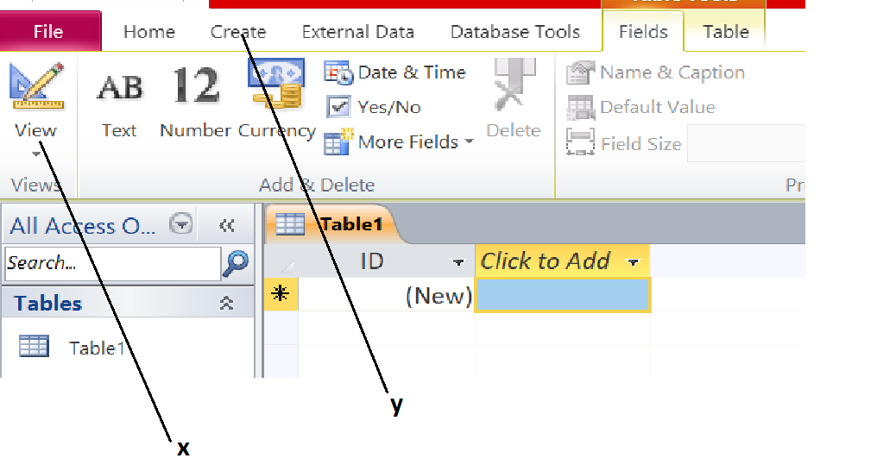
b. Identify the application program shown on the diagram
__________________________________________________________________ (1 mark)
c. State any two views found on the part labeled X
____________________________________________________________________________________________________________________________________________________
(2 marks)
d. Describe any two objects which can be created using the tab labeled Y
________________________________________________________________________________________________________________________________________________________________________________________________________________________________________________________________________________________________________
(4 marks)
- a. Define the term variable as used in programming
____________________________________________________________________________________________________________________________________________________
(1 mark)

- Explain any two situations which can prompt a programmer to develop new programs
________________________________________________________________________________________________________________________________________________________________________________________________________________________________________________________________________________________________________
(4 marks)
- Why it is important to test the program before its implementation? Give any two reasons
____________________________________________________________________________________________________________________________________________________
(2 marks)
- State any two characteristics of IPv6 addresses
____________________________________________________________________________________________________________________________________________________
(2 marks)
- a. With an example, describe “social networks”
______________________________________________________________________________________________________________________________________________________________________________________________________________________________
(3 marks)
- State any two functions of each of the following layers of OSI network model
- Data link layer
____________________________________________________________________________________________________________________________________________________
(2 marks)

- Transport layer
____________________________________________________________________________________________________________________________________________________
(2 marks)
- a. Give any three benefits of desktop publishing software
__________________________________________________________________________ ____________________________________________________________________________________________________________________________________________________
(3 marks)
- Describe the procedure for rotating an object in publisher 4 marks)
- Explain any two advantages of wireless networks
________________________________________________________________________________________________________________________________________________________________________________________________________________________________________________________________________________________________________
(4 marks)

Section B (45 marks)
Answer all the three questions in this section in the spaces provides

- a. With the aid of a diagram, describe ring network topology

___________________________________________________________________________________________________________________________________________________________________________________________________________________________________________________________________________________________________________________________________________________________________________________________________________________________________________________ (5 marks)
- Study the program extract written in Visual Basic and answer the questions that follow.
Module Module1
Sub Main()
Dim radius As Double
Dim area As Double
Console.WriteLine("Enter the radius of the circle:")
radius = Console.ReadLine()
area = 3.142 * radius * radius
Console.WriteLine(The area of the circle is:" area)
Console.ReadLine()
End Sub
End Module
- Identify any one arithmetic operator used in the program above.
_______________________________________________________________ (1 mark)
- Identify a statement having an error in the program above and write a correct one
______________________________________________________________ (2 marks)
- Mention any one variable used in the program above
______________________________________________________________ (1 mark)
- Describe any three common computer hardware related problems
__________________________________________________________________________________________________________________________________________________________________________________________________________________________________________________________________________________________________________________________________________________________________________________________________________________________________________________________________________________________________________________________________________________________________________________________________________________________________________________________________________________________
(6 marks)
- a. Outline the procedure for creating a columnar form using a wizard in MS Access
________________________________________________________________________________________________________________________________________________________________________________________________________________________________________________________________________________________________________________________________________________________________________________________________________________________________________________________________________________________________________________________________________________________________________________________________________________
(7 marks)
- Describe any two limitations of low-level programming languages.
____________________________________________________________________________________________________________________________________________________________________________________________________________________________________________________________________________________________________________________________________________________________________________________________________________________________________________________________
(4 marks)
- Explain the procedure how to solve the problem of hanging in computer systems
__________________________________________________________________________________________________________________________________________________________________________________________________________________________________________________________________________________________________________________________________________________________________________________
(4 marks)
- a. Describe the following inbuilt functions used in Spreadsheet and provide an example on each case
- Logical functions
____________________________________________________________________________________________________________________________________________________
(3 marks)
- Mathematical functions
______________________________________________________________________________________________________________________________________________________________________________________________________________________________
(3 marks)

b. Table 1 shows scores of top 3 students in Computer Studies. Use it to answer questions that follow.
A B C
1 | Student Name | Score | Grade
2 | Mambo Tasiyana | 71
3 | Mtonga Joshua | 92
4 | Ron Seth | 87

Write IF-function which can be used to work out grades of the 3 students based on the following grading system
70-79 = 3
80-85 = 2
86-100 = 1

(7 marks)
c. Explain why switches are described as intelligent hubs.
___________________________________________________________________________________________________________________________________________________________________________________________________________________________________ (2 marks)

END OF QUESTION PAPER
NB: This paper contains 10 printed pages.

